Smart Farmer-IOT Enabled Smart Farming Application

**Project Design Phase-I Solution Architecture**

|  |  |
| --- | --- |
| **TITLE** | **Smart Farmer-IOT Enabled Smart Farming**  **Application** |
| **DOMAIN NAME** | INTERNET OF THINGS |
| **TEAM ID** | PNT2022TMID22809 |

# Solution Architecture:

* The different soil parameters (temperature, humidity, light intensity, pH level) are sensed using different sensors and the obtained value is stored in IBM cloud.
* Arduino UNO is used as a processing unit which processes the data obtained fromsensors and weather data from weather API.
* Node red is used as a programming tool to wire the hardware, software and APIs.The MQTT protocol is followed for communication.
* All the collected data are provided to the user through a mobile application which was developed using MIT app inventor. The user could make decision through an app, whether to water the crop or not depending upon the sensorvalues.

# Solution Architecture Diagram:

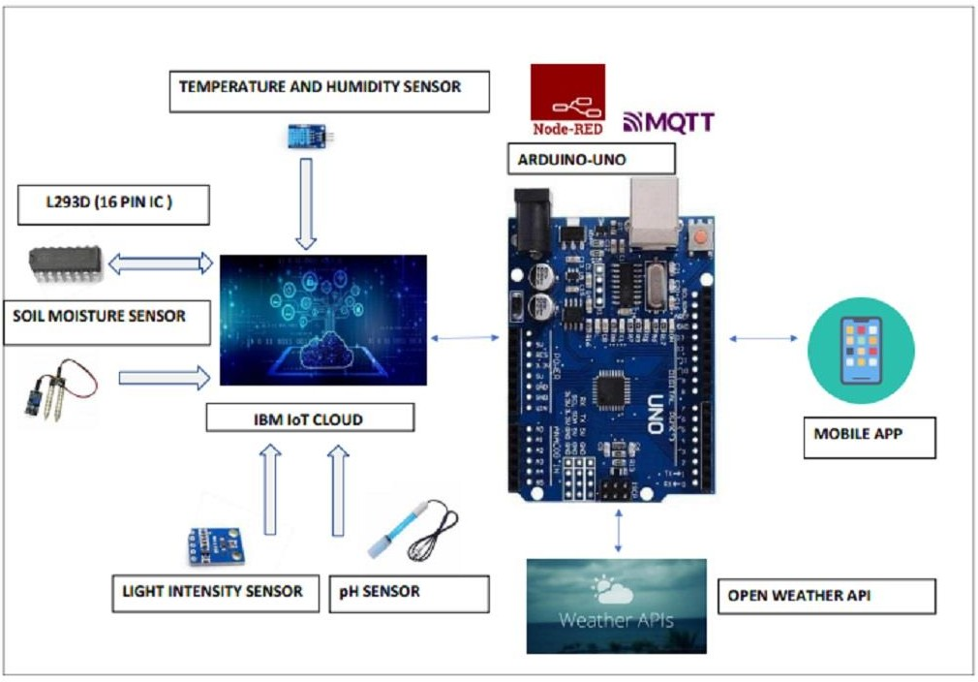

**Reference:** [**https://aws.amazon.com/blogs/industries/voice-applications-in-clinical-research-**](https://aws.amazon.com/blogs/industries/voice-applications-in-clinical-research-powered-by-ai-on-aws-part-1-architecture-and-design-considerations/)[**powered-by-ai-on-aws-part-1-architecture-and-design-considerations/**](https://aws.amazon.com/blogs/industries/voice-applications-in-clinical-research-powered-by-ai-on-aws-part-1-architecture-and-design-considerations/)